Are you #LitFitNEO?
It’s Easy!

- Download the App you want.
- Use it 3 times.
- Post to social media that you are #LitFitNEO

STEP 1
Go to

Type the name of the app in the Search box. Other options are Scan the QR code or Click on the link.

Learning Upgrade:
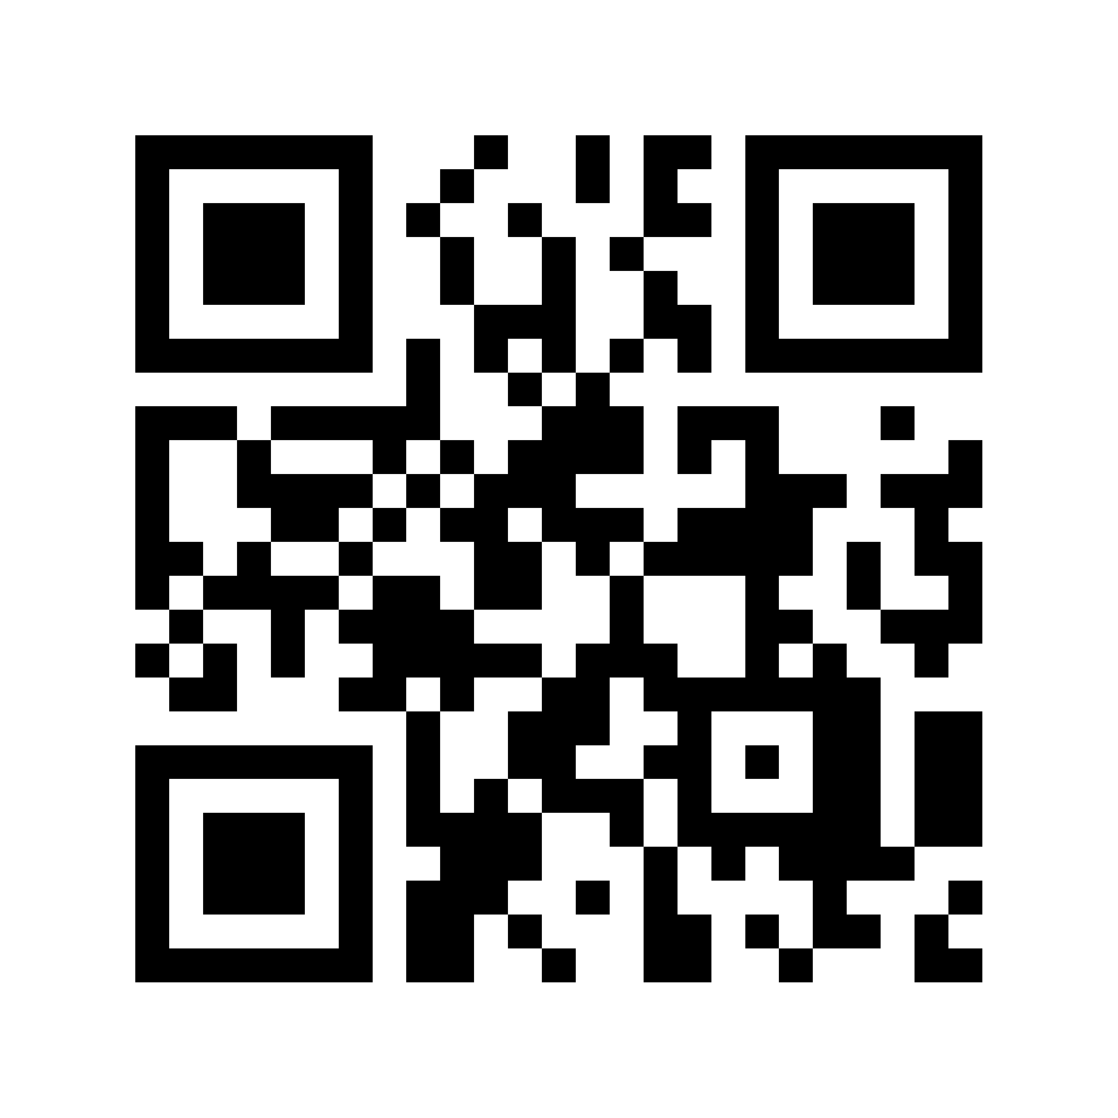
https://abc.xprize.org/lu4422

Amrita Learning:
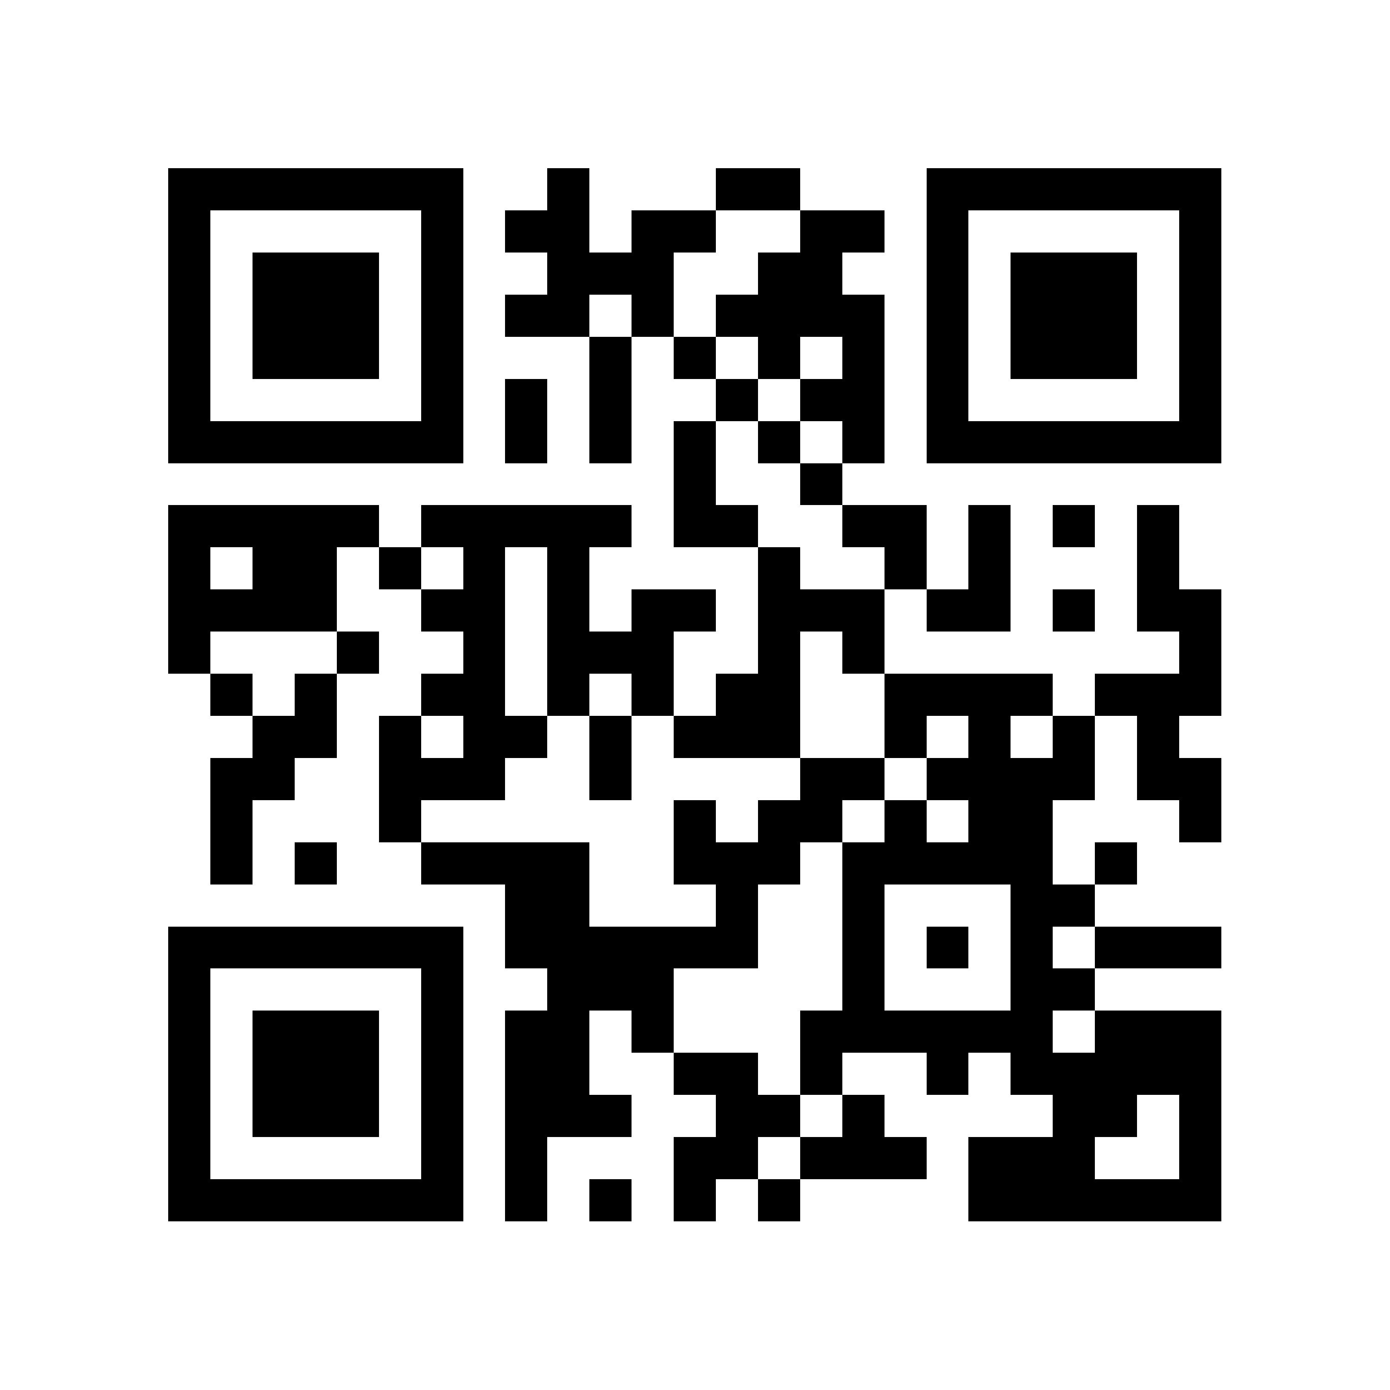
https://abc.xprize.org/ac4422

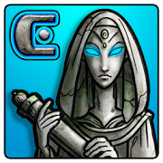 Codex: Lost Words of Atlantis
https://abc.xprize.org/pw4422

Cell Ed:
https://abc.xprize.org/ce4422

- Click on Install
- Open the App
- Type in the LitFitNEO Code: 4422

STEP 2
Use the app at least 3 times. When you use the app 3 times our community has a chance to win the Adult Literacy XPRIZE Communities Competition. If we win, we’ll have $100,000 to help people meet their educational goals!

STEP 3
Go to Twitter, Facebook, or Instagram and post that you are #LITFITNEO! Tell us what you think about the app after you have used it on three separate days and you could win a gift card. Try another app and post again!

