Codex: Lost Words of Atlantis  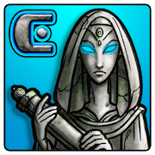  https://abc.xprize.org/pw4422  - Best used by English language learners or low literacy learners.  - Can be downloaded on an Android phone only.  - Does not have a placement test.  - Content areas are English and Reading.  - Designed for adults, but is kid-friendly.  - Uses games.  - English and Spanish available. | Cell Ed  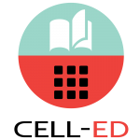  https://abc.xprize.org/ce4422  - Best used by English language learners.  - Can be downloaded on an Android or Apple phone. Only Android users count for the competition.  - Does not have a placement test.  - Content area is English.  - Designed for adults.  - Uses text messages.
XPRIZE COMPETITION
LitFitNEO Code: 4422
APPROPRIATE FOR SPECIAL POPULATIONS

