Northeast Ohio Skill Corps
Host Site Application
Intent to Apply

2018-2019 AmeriCorps Service Year

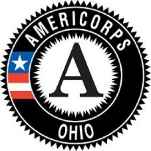
Due on March 22, 2018, 5:00 pm

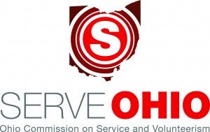

INTENT TO APPLY INSTRUCTIONS
Sections I and II are required from ALL applicants intending to apply for consideration as a Host Site with an Ohio AmeriCorps Service Member for 2018-2019.

Section I and Section II are due no later than 5:00pm on March 22, 2018.

SECTION I – Applicant Information
Organization Name (applicant):
Contact Person & Title:
Email Address:
Address:
City/State/Zip and Telephone #:
The Applicant is a (check one):
________ 501(c)3 Nonprofit/CBO
________ Education Institution
________501(c)3 Faith-Based Organization
________Other: _____________________________________

Number of Members and Slots to be requested: Select all that apply
__________Full-time (1700 hours; 1.0 MSY) __________Half-time (900 hours; .5 MSY)

SECTION II – Concept Paper/Program Narrative Instructions
- Fully respond to the questions below.
- The Program Narrative should be no more than 4 pages in length, typed and double-spaced in Times New Roman, 12-point font size with one-inch margins with the first page on organizational letterhead.
- Number each response to the corresponding question and number each page of the Program Narrative.
- Submit the Program Narrative with the completed Section I via email to Sandra Buckner, AmeriCorps NEO Skill Corps Program Manager at sbuckner@univeristysettlement.net no later than 5:00pm on March 15, 2017.

- Answer all questions as thoroughly as possible:
- What activity or service will the AmeriCorps member provide to address the community need/issue of Financial Literacy, Adult Education or Workforce Development?
- Where will the members provide the activity?
- How do you know the proposed member activity or service will address the community need/issue identified?
- How will community volunteers be involved to address the need/issue?
- How will success be measured?
- What qualifications/education/experience will an AmeriCorps member need for a positive experience and to add value to your program?
- Estimate the number of individuals that will serve at your organization by the AmeriCorps program?
- Approximately, what percent of your current clients meet the “Economically Disadvantaged” definition of AmeriCorps? Economically disadvantaged: Must be receiving or met the income eligibility requirements to receive: TANF, Food Stamps (SNAP), Medicaid, SCHIP, Section 8 housing assistance or have a poor credit score OR at least 60 days behind on one or more personal/family account.

